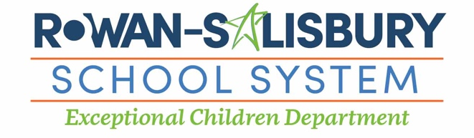
Preschool Evaluation Center
Koontz Elementary School
685 E. Ritchie Road
Salisbury NC 28146
704-680-6852 – Phone
855-213-1599 - Fax

Please complete this form and fax it to (855) 213-1599 or email it to Kaitlyn Bettis @ smithkc@rss.k12.nc.us
Please attach child’s birth certificate to this form BEFORE submitting.
Notifying Agency: _______________________________ Phone: _________________________ Fax: _______________________

EISC Coordinator: ____________________________________________ Date: ____________________
Family Contact Information – To be completed by notifying agency
First: __________________________  Middle: ________________________  Last: ___________________________ | DOB: ______________________  Gender: ____________________  Race: ____________________  Hispanic: ___________________ | Street: ____________________________ City: ______________________________  Zip Code: __________________________
Mother: ________________________  Father: _________________________  Other Relative: ___________________  DSS Social Worker: _______________ | Preschool: __________________  Language: __________________  Interpreter Needed? _________ | Phone 1: ___________________________  Phone 2: ___________________________  Email 1: ___________________________  Email 2: ____________________________
Reasons for Notification to Exceptional Children Preschool Program – To be completed by notifying agency
Concerns:

YES __________ I give consent for my child to participate in a developmental screening and give consent for RSS to
communicate with the agency above for the purposes listed above
NO __________ I do not want to pursue services through the Exceptional Preschool Program at this time

Parent/Guardian Signature: _______________________________________________________Date:_______________

EC Preschool Program Response Form – To be completed by RSS PK Outreach Staff

DEC 1 Date: _____________________
Notes:

__________________________________________________________________________________________________________________________________________________________________________________________
_____________________________________________________________________________________________
_____________________________________________________________________________________________
_____________________________________________________________________________________________
_____________________________________________________________________________________________
_____________________________________________________________________________________________
_____________________________________________________________________________________________
_____________________________________________________________________________________________
_____________________________________________________________________________________________
_____________________________________________________________________________________________
_____________________________________________________________________________________________
_____________________________________________________________________________________________
_____________________________________________________________________________________________
_____________________________________________________________________________________________
_____________________________________________________________________________________________
____________________________________________________________________________________________________________________________________________________________________________________________________________________________________________________________________________________________________________________________________________________________________________________

The Rowan-Salisbury School System administers all educational programs, employment activities and admissions without discrimination because of race, religion, national or ethnic origin, color, age, military service, disability, or gender, except where exemption is appropriate and allowed by law.

